Project: Classes Weight: 20%

Type: Group Assignment
- Students should ONLY USE programming constructs covered in the course material.
- Submissions using programming concepts or formats that are not covered in the course material, while True, or while Boolean_flag will be penalized.
  - Penalty with no limit could be applied
  - Minimum penalty is 25% per a concept or format
- Late submissions will not be accepted

Scenario
YYC Little Steps Daycare needs a system to manage children's daily attendance and supervision. The daycare wants to track which children are currently checked in, monitor availability of slots, and manage check-in/check-out processes.
The daycare has hired your team to create a Child Check-In Management System tailored to its daily operations.
The system should support the following features:
- Adding and removing a child record
- Checking a child into the daycare
- Checking a child out of the daycare
- Viewing all children and their attendance status

Equipment and Materials
For this assignment, you will need:
Python IDE
Git software
GitHub repository

Instructions
This assignment consists of two parts, both completed outside of class time. See the course schedule and Brightspace for exact dates. Rubrics are available in Brightspace.
Project Part 1: (No Submission)
- Create the Child class as outlined in the document and verify its correct operation by running the test program provided.
- Choose a descriptive file name for the Child class source code (recommended filename: child.py)
- Test the Child class and create a sample run (as a .txt file) by running the supplied test_child.py program, which outputs data and reports errors in the implementation of the class.
- Each student is encouraged to individually complete Part 1. At least, group members MUST equally participate in Part 1.
Project Part 2: (Submission is required)
- Have one member of your group set up a GitHub repository for Part 2 of this project.
a. Make sure that this GitHub repository is private.
b. Add group members and your instructor as collaborators.
- Create a separate branch in GitHub for each group member, containing the part they will work on.
a. The branch name should include the task name and the student name.
- Develop the code for the Child Management Module as specified in this document. As a team, you will also need to assess each member's Child class and then finalize one version for your group's solution.
- GitHub must be effectively used for group collaboration.
- Ensure all group members update their parts to their respective GitHub branches.
- The final project code must be pushed to master/main on GitHub.
- Check your solution against the detailed marking criteria available in Brightspace.

- Create a project video.
Each group will submit a 10-15 minute video to Brightspace or their GitHub Repository (either as a URL or an uploaded video file). In the video:
- EACH team member will introduce themselves -- camera should be on. Please use laptop camera/screen share to create video (not a phone).
- Provide a demonstration of the application covering all the functionality corresponding to the provided sample run(s).
- Provide a demonstration of the sample runs generated by your program.
- Share the group's final solution (Python code) on screen and have EACH team member explain the code that they developed and part of sample runs. A debugger may be used to step through sections of code (optional).
- Submit the following files to Brightspace:
- Project Submission
  - A ZIP file for the whole project folder that includes:
    - The code of the Child class and management module (.py files).
    - A copy of your sample runs (.txt file) that correspond to the provided sample runs.
    - All data files updated by program after the test runs have been completed.
  - A link to your group's GitHub project repository
    - The GitHub project repository should include:
      - The code of the program that you implemented (.py files).
      - A copy of your sample runs (.txt files) that correspond to the sample runs provided.
      - All data files updated by program after the test runs have been completed.
  - Presentation video.
    - Upload the video or its URL to Brightspace.
  - PDF/DOC peer assessment file

Child Check-In System Details
YYC Little Steps Daycare requires that the child check-in system track the following information for each child:
- Child ID
- Age group:
- Toddler
- Preschool
- School Age
- Daily fee (in dollars)
- Guardian name (empty string if child is not checked in)
The child check-in system needs to provide the following functionality:
- Loading existing data from a file
- Allowing the user to select and perform any of the following menu functions (continuously until the user chooses to exit the system):
    - Add Child
    - Remove Child
    - Check In Child
    - Check Out Child
    - View All Children
    - Exit
- Allowing the user to save all child data to a file when they exit the program.
A senior software developer has already done some design work on the Child class as well as the core functions required for the child check-in module. Please refer to the detailed information in the following two sections as you complete both programming parts of this project.
Part 1: Child Class
Properties/Attributes (must be private)
- child_id
- age_group
- fee
- guardian_name

Methods
Method Name | Description
Constructor | - __init__() initializes all attributes.  - The constructor should have parameters for child_id, age_group , fee, and guardian_name (default empty string).
Getters | - Implement one getter method for each Child property. The getter method should return the value of the property.
Setters | - Implement a setter method for each Child property. The setter method should set the property to the parameter value received.
is_present() | - Returns True if child is checked in, False otherwise.
check_in() | - Accepts a guardian_name parameter to set the guardian_name property
check_out() | - Resets the guardian_name property to empty string
__str__() | - Returns a string representation of a Child object formatted for display, e.g.:  Child C101 | Preschool | Fee: 40.0 | Checked in by Sarah Lee  Child C102 | Toddler | Fee: 50.0 | Not Checked In
Part 2 - Child Management Module
Create a separate module (management.py file) for your Child check-in management application code which will include various functions, including a main(), an entry function, that controls the overall processing. The functions listed below are required but you may use additional functions too.
Function Name | Description
load_children(file_path) | - Called by main() at startup.  - Receives a file path to the file containing child data.  - Opens the file and reads each line.  - Parses each line into child_id,age_group,fee,guardian_name  - Creates Child objects and adds them to a list.  - Returns the list of Child objects.
save_children(file_path, child_list) | - Called when exiting the system.  - Receives a file path where the file will be saved and list of child objects to save (e.g., child_list).  - Opens the file for writing.  - Iterates through the child_list and writes each child data in CSV format.  - Closes the file.
find_child_index(child_list, child_id) | - Receives the list of Child objects (e.g., child_list) and child_id parameters.  - Searches the list for a child by its child_id.  - Returns the index if found, otherwise returns -1.
add_child(child_list) | - Receives the current list of Child objects (e.g., child_list).  - Asks user for Child_id, age group, and fee.  - Validates inputs (Child_id must be numeric, Child_id must be unique).  - If the Child_id does not exist, asks user for age group, and fee.  - Creates new Child object and appends to list.  - Displays appropriate success/error messages.  - Returns the updated child_list.
remove_child(child_list) | - Receives the current list of Child objects (e.g., child_list).  - Asks user for Child_id.  - Validates the input (Child_id must be numeric, Child_id must exist).  - Checks if child is already checked in (using is_available() method). Child is not currently checked in  - If checked in, removes the child from the child list.  - Displays appropriate success/error messages.  - Returns the updated child_list.
check_in_child(child_list) | - Receives the current list of Child objects (e.g., child_list).  - Asks user for child ID and guardian name  - Validates inputs and finds the child.  - child ID must be a number.  - Guardian name not empty.  - Child exists  - Child not already checked in  - Checks if child is checked in (using is_available() method).  - If not checked in, display “Child is already checked in”  - Child not already checked in , calls check_in() method with child name and displays appropriate success message.  - Returns updated child_list.
check_out_child(child_list) | - Receives the current list of Child objects (e.g., child_list).  - Asks user for child ID.  - Validates input and finds if child is currently checked in.  - Checks if child is already checked in (using is_available() method).  - If checked in, calls check_out() method.  - Displays appropriate success/error messages.  - Returns updated child_list.
view_all_children(child_list) | - Receives the current list of Child objects (e.g., child_list).  - If list is empty, displays " No children records available."  - Otherwise, display all children using __str__()  - Display summary:  - Total children  - Checked-in children  - Not checked-in children
main() | - Entry point for the Child Check-in System.  - Coordinates the overall processing:  - Load data from file  - Display menu repeatedly until user chooses to exit and get user selection  - Call appropriate functions based on selection  - Save data to file before exiting
Note that:
- All functions listed above (except for main()) should receive a [list of child objects].
- All the processing will be done on the list of Child objects.
- The list of Child objects is only saved to bookings.csv when exiting the program.
Sample Run: see Project Sample Run SPSU2026 document.
Make sure your program output matches this sample run.
Starting child Data File: see child.csv.
Make sure that your application maintains the same comma-separated format established in this file. Here is the file content.
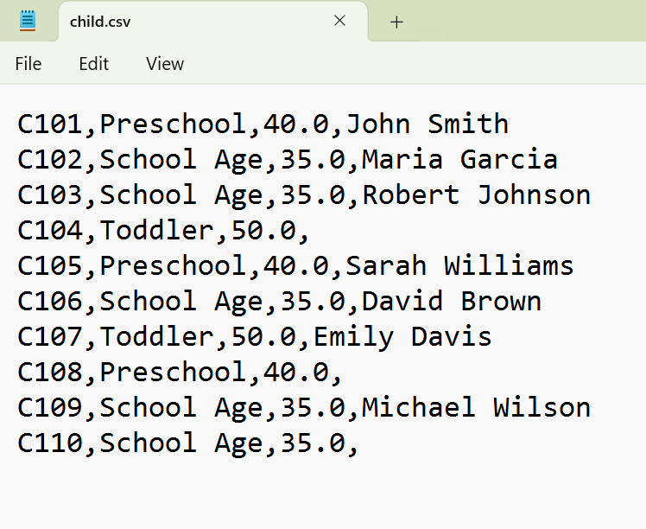

Output Child Data File
The following is a sample of bookings.csv file after adding Child C110 and checking-in a guardian.

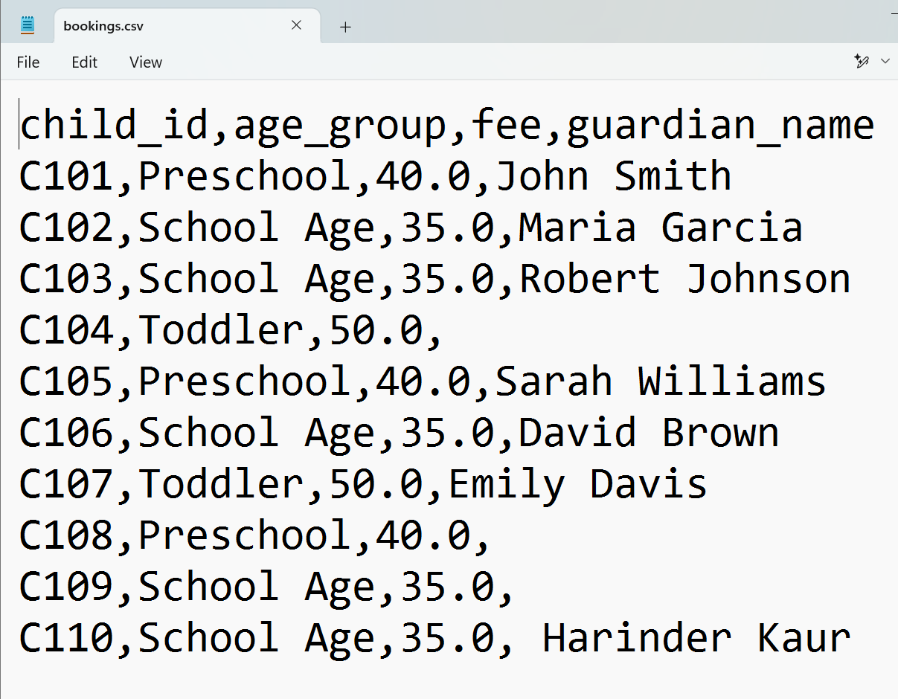

Peer Assessment
Please accurately use and complete the following table. Each member should assign a mark out of 10 to other group members.
- The peer assessment should be completed accurately and honestly
  - Deduction will be applied if it is not
- All members should equally participate in the project.
  - The grade of each member will be based on her/his participation
- Each member should assess the contribution/participation of all other group members.
- Each member should assign a mark out of 10 to other members.
- Please use the following table to complete the peer assessment. Marks/tasks are just samples.
  - A deduction will be applied when using a different format
 | Member 1 Name | Member 2 Name | Member 3 Name | Tasks Description
Member 1 Name | -- | 9 | 10 | Task 1 Description
Member 2 Name | 10 | -- | 10 | Task 2 Description
Member 3 Name | 10 | 9 | -- | Task 3 Description
Average | 10 | 9 | 10

Grading
Item | Percentage
Working Code | 60%
Style | 10%
Documentation | 5%
Testing | 10%
Video | 5%
Version Control and GitHub training certificate | 7%
Pee Assessment | 3%
Total | 100%

Marking Criteria

Rubric is available on Brightspace.

